INF407: Modern Issues in Databases
M3-2 – Refreshing the Data Warehouse
Niharika jakkula

Current records in student table:
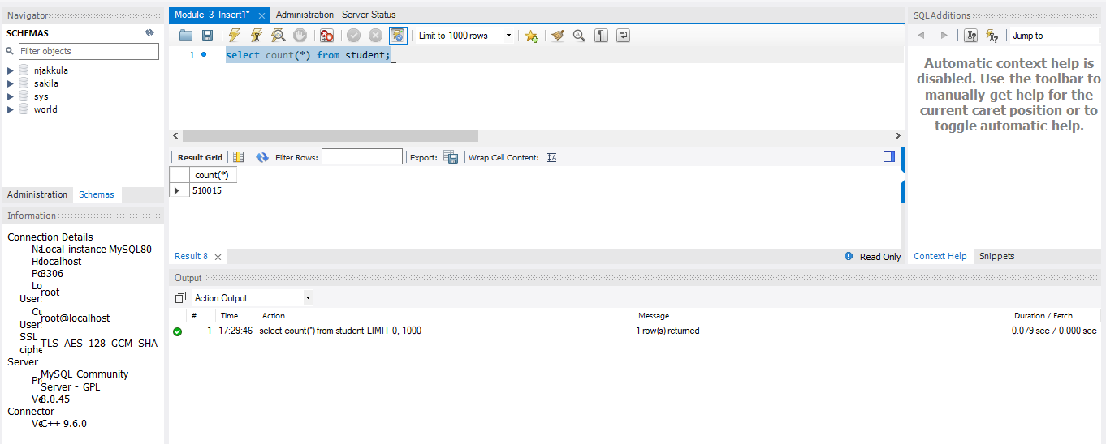

With our current indexes intact, run the insert query in “3-2_Insert1” and record the amount of time it took to run.
Indexes check
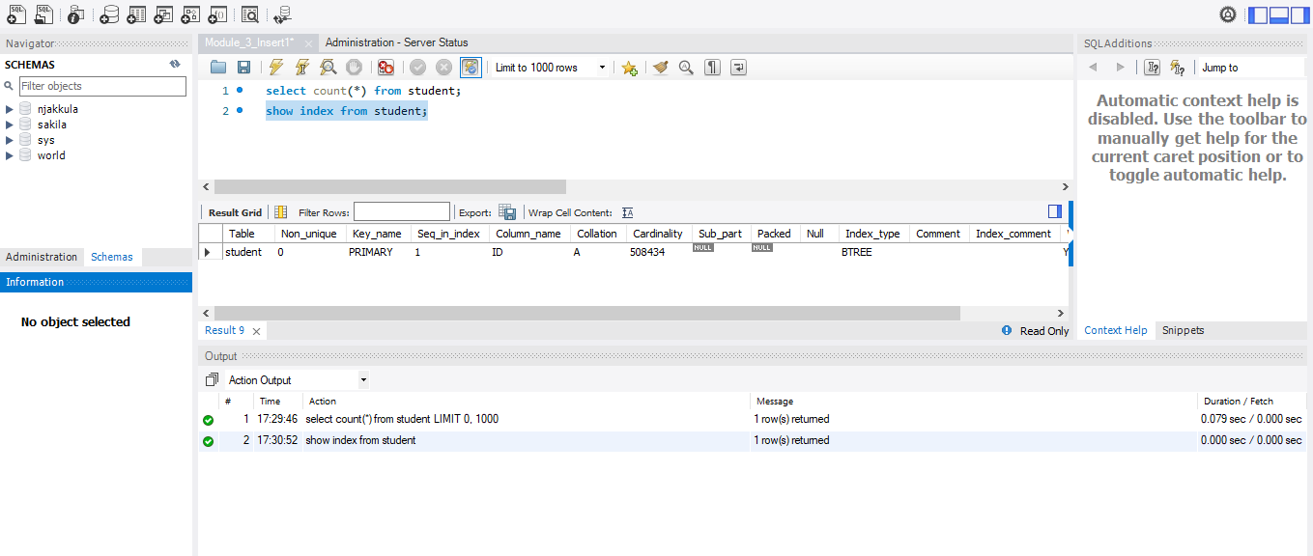

Deleted the rows where ID>=515000 (From the insert 3-1)
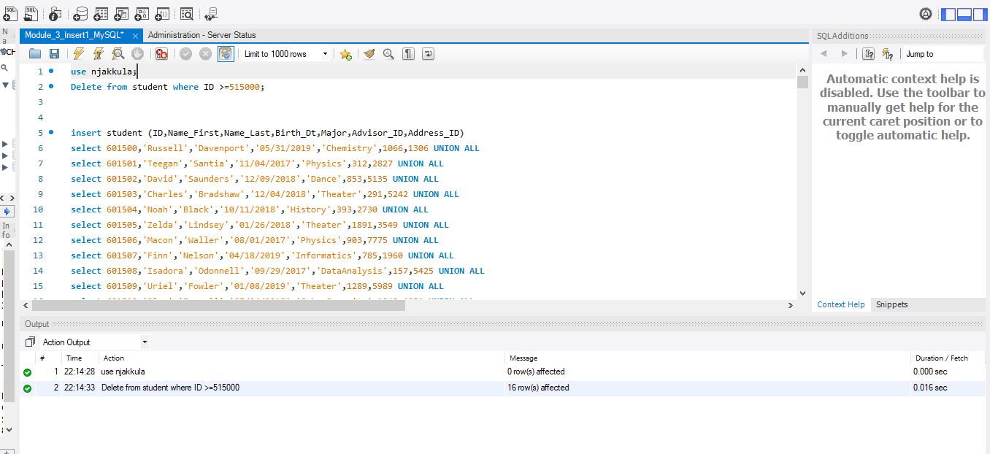
Successfully deleted check
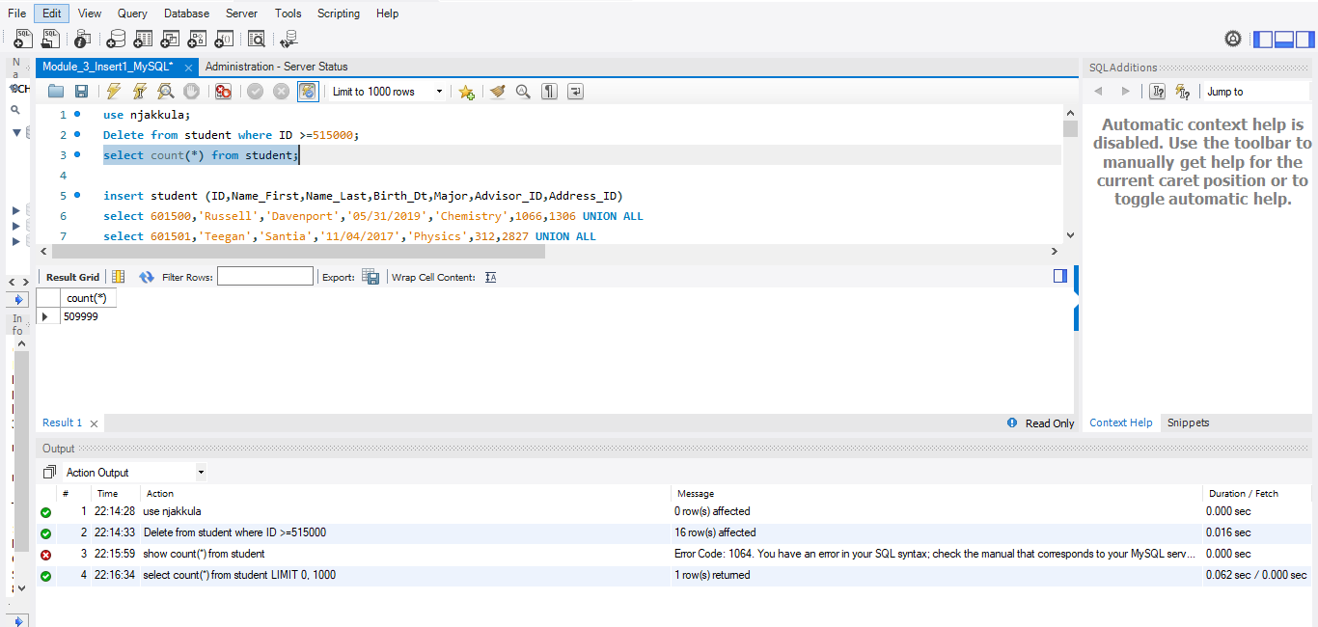run the insert query in “3-2_Insert1”
The insert query processed in multiple batches (5000 rows per batch, with a final batch of 3500 rows). The total execution time was approximately 0.939 seconds.
The insert query executed in multiple batches, which contributed to the total execution time.
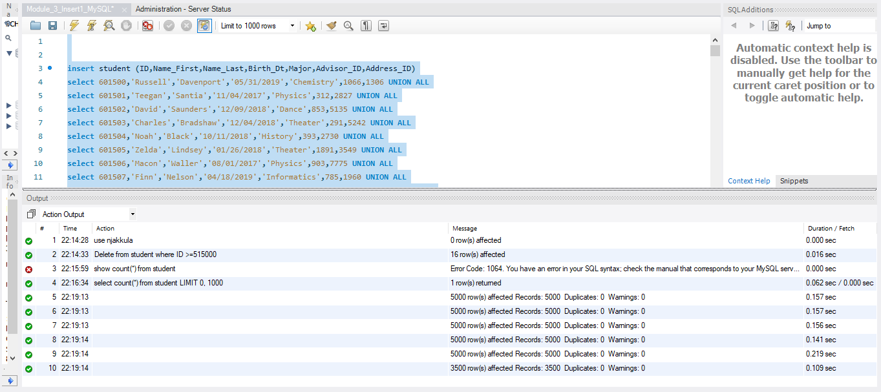
Re-Run this query. What error did you encounter and why?
This happened because:
- Student table has a PRIMARY KEY Index on ID
- PRIMARY KEY values must be unique
- When we re-ran the same insert query, it tried to insert:
  - ID = 601500 (and others) again
- But those IDs were already inserted in the first run
So MySQL blocked it to prevent duplicate records

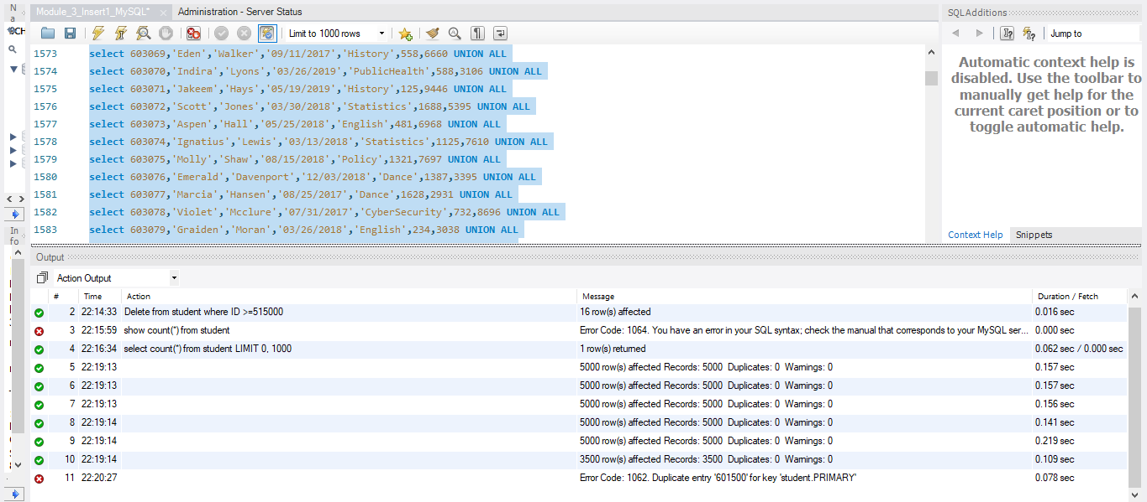

Part:2
Drop indexes in your table:
The provided query in “3-2_Insert2” to drop the index did not work because my index was defined as a primary key. In MySQL, primary keys cannot be dropped using the DROP INDEX command. Therefore, I modified the query to:
ALTER TABLE student DROP PRIMARY KEY;
This successfully removed the primary key constraint before running the insert query.
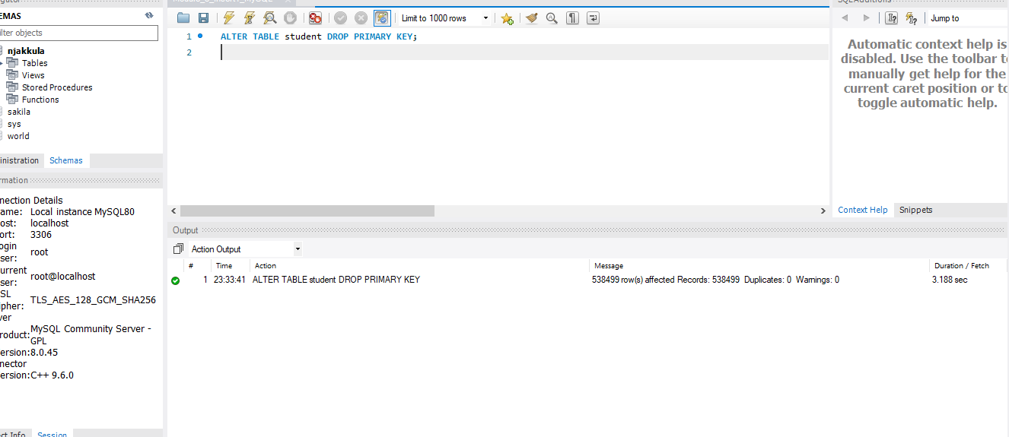
As mentioned in the Insert3-2, deleted the old insert 3-1 records
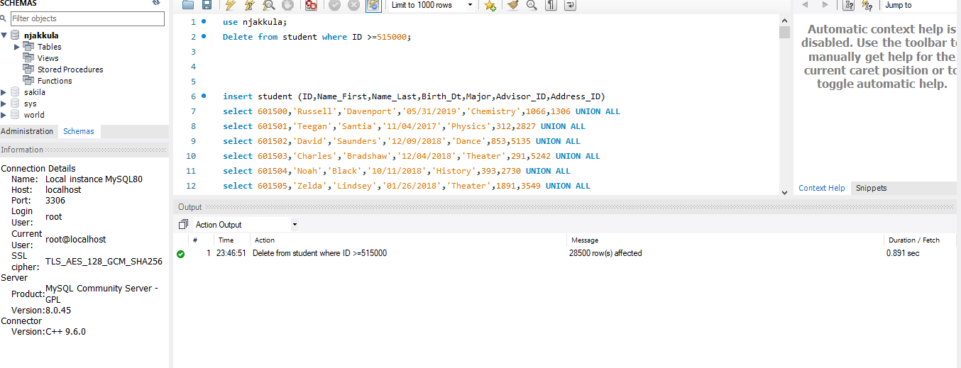
run the “3-2_Insert2”
The total execution time was approximately 0.938 seconds.

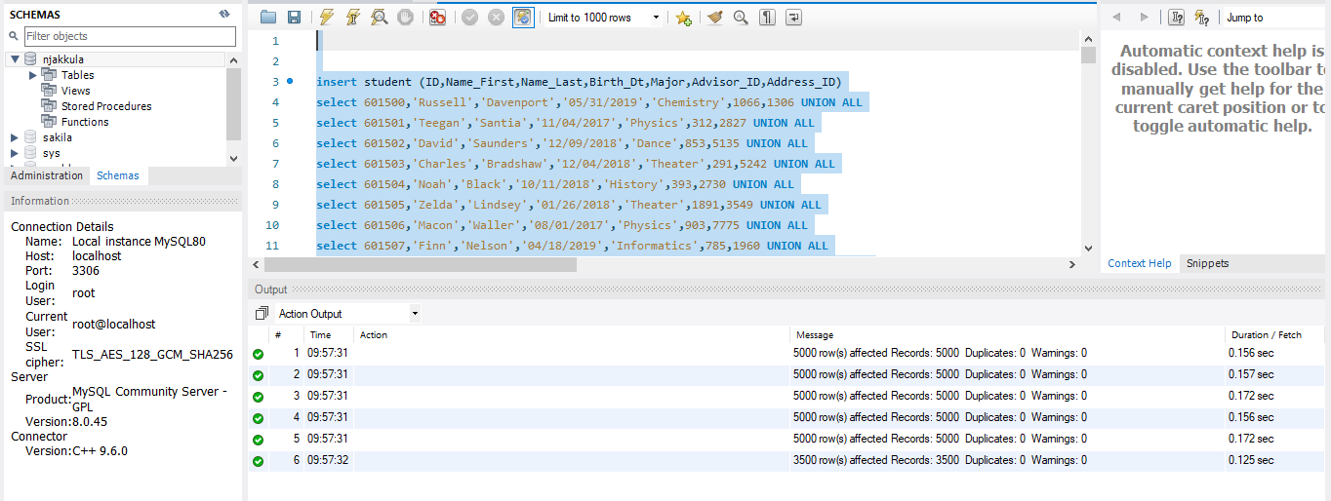
Compare this to the first query – note time differences in terms of percentage of change, not just seconds.
((Old - New) / Old) * 100
((0.939 - 0.938) / 0.939) * 100 ≈ 0.11%
Insert WITHOUT index is slightly faster (but almost the same)
Summary:
In this assignment, The performance of inserting records into the Student table was evaluated with and without indexes. First, the existing records where the ID was greater than or equal to 515000 were deleted. Then, the insert query (3-2_Insert1) was executed with indexes intact, and the total execution time was approximately 0.939 seconds. The query executed in batches, where 5000 records were inserted at a time across six runs, and the final batch inserted 3500 records.
When the same query was re-run, MySQL returned Error Code 1062, indicating a duplicate entry for the primary key. This occurred because the insert statement attempted to insert records with IDs that already existed in the table. Since the ID column is defined as a primary key index and must be unique, the database rejected the duplicate values.
For the second part (3-2_Insert2), records where the ID was greater than or equal to 515000 were deleted to reset the dataset before executing the insert query. This ensured a consistent environment for comparing performance with and without indexes. And also the index needed to be removed before running the insert query.
After removing the primary key constraint, the insert query was executed again. The total execution time for this run was approximately 0.938 seconds. The percentage improvement in performance was calculated to be about 0.11%, indicating a very slight improvement when the index was removed.
The results show that removing the index slightly improved insert performance because the database did not need to maintain index structures during insertion. However, the difference was minimal, likely due to the relatively small dataset size.
From a performance perspective, it is generally recommended to drop indexes before performing large bulk inserts and recreate them afterward. This reduces overhead and improves efficiency. However, when indexes are removed, there is a risk of inserting duplicate records because constraints such as the primary key are no longer enforced during the insert process.
When the index (or primary key) is recreated after the insert, the database will attempt to rebuild the index and enforce uniqueness. If duplicate values exist in the column, the index creation will fail and return an error. Therefore, it is important to ensure that the data being inserted is clean and does not contain duplicates before recreating the index.

